**Assignment(1)**

**Class:BBA-I(Sem-I)**

**Subject: Business Mathematics**

## Topics: matrices and types of matrices, Exponential and Logarithmic Functions

**Submitted To:**

Ashu Garg

Prof.of Management Department

**Ques1:What is matrices and types of matrices**?

**Ans.Matrix**, a [set](https://www.britannica.com/topic/set-mathematics-and-logic) of numbers arranged in rows and columns so as to form a rectangular [array](https://www.britannica.com/dictionary/array). The numbers are called the elements, or entries, of the matrix. Matrices have wide applications in [engineering](https://www.britannica.com/technology/engineering), [physics](https://www.britannica.com/science/physics-science), [economics](https://www.britannica.com/topic/economics), and [statistics](https://www.britannica.com/science/statistics) as well as in various branches of [mathematics](https://www.britannica.com/science/mathematics). Matrices also have important applications in [computer graphics](https://www.britannica.com/topic/computer-graphics), where they have been used to represent rotations and other transformations of images.

Historically, it was not the matrix but a certain number associated with a square array of numbers called the [determinant](https://www.britannica.com/science/determinant-mathematics) that was first recognized. Only gradually did the idea of the matrix as an algebraic entity emerge. The term *matrix* was introduced by the 19th-century English mathematician [James Sylvester](https://www.britannica.com/biography/James-Joseph-Sylvester), but it was his friend the mathematician [Arthur Cayley](https://www.britannica.com/biography/Arthur-Cayley) who developed the algebraic aspect of [matrices](https://www.britannica.com/dictionary/matrices) in two papers in the 1850s. Cayley first applied them to the study of systems of linear equations, where they are still very useful. They are also important because, as Cayley recognized, certain sets of matrices form algebraic systems in which many of the ordinary laws of [arithmetic](https://www.britannica.com/science/arithmetic) (e.g., the [associative](https://www.britannica.com/science/associative-law) and [distributive laws](https://www.britannica.com/science/distributive-law)) are valid but in which other laws (e.g., the [commutative law](https://www.britannica.com/science/commutative-law)) are not valid.

If there are *m* rows and *n* columns, the matrix is said to be an “*m* by *n*” matrix, written “*m* × *n*.” For example,Matrix.

is a 2 × 3 matrix. A matrix with *n* rows and *n* columns is called a square matrix of order *n*. An ordinary number can be regarded as a 1 × 1 [matrix](https://www.britannica.com/dictionary/matrix); thus, 3 can be thought of as the matrix [3]. A matrix with only one row and *n* columns is called a row [vector](https://www.britannica.com/science/vector-physics), and a matrix with only one column and *n* rows is called a column [vector](https://www.britannica.com/science/vector-mathematics).

In a common notation, a [capital letter](https://www.britannica.com/topic/majuscule) denotes a matrix, and the corresponding [small letter](https://www.britannica.com/topic/minuscule) with a double subscript describes an element of the matrix. Thus, *aij* is the element in the *i*th row and *j*th column of the matrix *A*. If *A* is the 2 × 3 matrix shown above, then *a*11 = 1, *a*12 = 3, *a*13 = 8, *a*21 = 2, *a*22 = −4, and *a*23 = 5. Under certain conditions, matrices can be added and multiplied as individual [entities](https://www.britannica.com/dictionary/entities), giving rise to important mathematical systems known as matrix algebras.

Matrices occur naturally in systems of [simultaneous equations](https://www.britannica.com/science/system-of-equations). In the following system for the unknowns *x* and *y*,Equations.the array of numbersMatrix.is a matrix whose elements are the coefficients of the unknowns. The solution of the equations depends entirely on these numbers and on their particular arrangement. If 3 and 4 were interchanged, the solution would not be the same.

**Types of Matrices**

Different types of Matrices and their forms are used for solving numerous problems. Some of them are as follows:

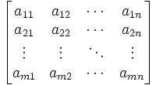

**1) Row Matrix**

A row matrix has only one row but any [number](https://www.toppr.com/guides/maths/knowing-our-numbers/operations-on-numbers/) of columns. A matrix is said to be a row matrix if it has only one row. For example,

A=[−1/2√523]

is a row matrix of order 1 × 4. In general, A = [aij]1 × nis a row matrix of order 1 × n.

**2) Column Matrix**

A column matrix has only one column but any number of rows. A matrix is said to be a column matrix if it has only one column. For example,

A=⎡⎣⎢⎢⎢0√3−11/2⎤⎦⎥⎥⎥

is a column matrix of order 4 × 1. In general, B = [bij]m × 1 is a column matrix of order m × 1.

**3) Square Matrix**

A square matrix has the number of columns equal to the number of rows. A matrix in which the number of rows is equal to the number of columns is said to be a [square](https://www.toppr.com/guides/maths/squares-and-square-roots/) matrix. Thus an m × n matrix is said to be a square matrix if m = n and is known as a square matrix of order ‘n’. For example,

A=⎡⎣⎢33/24−1√3/2301−1⎤⎦⎥

 is a square matrix of order 3. In general, A = [aij] m × m is a square matrix of order m.

**4) Rectangular Matrix**

A matrix is said to be a rectangular matrix if the number of rows is not equal to the number of columns. For example,

A=⎡⎣⎢⎢⎢⎢33/247/2−1√3/23201−1−5⎤⎦⎥⎥⎥⎥

is a matrix of the [order](https://www.toppr.com/guides/quantitative-aptitude/number-series/order-and-ranking/) 4 × 3

**5) Diagonal matrix**

A square matrix B = [bij] m × m is said to be a diagonal [matrix](https://www.toppr.com/guides/maths/matrices/matrix/) if all its non-diagonal elements are zero, that is a matrix B =[bij]m×m is said to be a diagonal matrix if bij = 0, when i ≠ j. For example,

A=[4][−1002]⎡⎣⎢3000−50002⎤⎦⎥

are diagonal matrices of order 1, 2, 3, respectively.

**6) Scalar Matrix**

A diagonal matrix is said to be a scalar matrix if all the elements in its principal diagonal are equal to some non-zero constant. A diagonal matrix is said to be a scalar matrix if its diagonal elements are equal, that is, a square matrix B = [bij]n × n is said to be a [scalar](https://www.toppr.com/guides/physics/work-energy-and-power/the-scalar-product/) matrix if

* bij = 0, when i ≠ j
* bij = k, when i = j, for some constant k.

For example,

A=[4][−100−1]⎡⎣⎢300030003⎤⎦⎥

 are scalar matrices of order 1, 2 and 3, respectively.

**7) Zero or Null Matrix**

A matrix is said to be zero matrix or null matrix if all its elements are zero.  
For Example,

A=[0][0000]⎡⎣⎢000000000⎤⎦⎥

are all zero matrices of the order 1, 2 and 3 respectively. We denote zero matrix by O.

**8) Unit or Identity Matrix**

If a square matrix has all elements 0 and each diagonal elements are non-zero, it is called identity matrix and denoted by I.  
Equal Matrices: Two matrices are said to be equal if they are of the same order and if their corresponding elements are equal to the square matrix A = [aij]n × n is an identity matrix if

* aij = 1 if i = j
* aij = 0 if i ≠ j

We denote the identity matrix of order n by In. When the order is clear from the context, we simply write it as I. For example,

A=[1][1001]⎡⎣⎢100010001⎤⎦⎥

are identity matrices of order 1, 2 and 3, respectively. Observe that a scalar matrix is an identity matrix when k = 1. But every identity matrix is clearly a scalar matrix.

**9) Upper Triangular Matrix**

A square matrix in which all the elements below the diagonal are zero is known as the upper triangular matrix. For example,

A=⎡⎣⎢300−540709⎤⎦⎥

**10) Lower Triangular Matrix**

A square matrix in which all the elements above the diagonal are zero is known as the upper triangular matrix. For example,

A=⎡⎣⎢30−5047009⎤⎦⎥

## Ques2: What are Exponential and Logarithmic Functions?

**Ans. Exponential Function Definition:**

An exponential function is a Mathematical function in the form y = f(x) = bx, where “x” is a variable and “b” is a constant which is called the base of the function such that b > 1. The most commonly used exponential function base is the transcendental number e, and the [value of e](https://byjus.com/maths/value-of-e/) is equal to 2.71828.

Using the base as “e” we can represent the exponential function as y = ex. This is called the natural exponential function. However, an exponential function with base 10 is called the common exponential function.

Learn more about [exponential functions](https://byjus.com/maths/exponential-functions/) here.

**Logarithmic Function Definition:**

If the inverse of the exponential function exists then we can represent the logarithmic function as given below:

Suppose b > 1 is a real number such that the logarithm of a to base b is x if bx = a.

The logarithm of a to base b can be written as logb a.

Thus, logb a = x if bx = a.

In other words, mathematically, by making a base b > 1, we may recognise logarithm as a function from positive real numbers to all real numbers. This function is known as the logarithmic function and is defined by:

logb : R+ → R

x → logb x = y if by = x

If the base b = 10, then it is called a common logarithm and if b = e, then it is called the natural logarithm. Generally, the natural logarithm is denoted by ln.

| **Read more:**   * [Exponent](https://byjus.com/maths/exponent/) * [Logarithmic Functions](https://byjus.com/maths/logarithmic-functions/) * [Real Numbers](https://byjus.com/maths/real-numbers/) * [Derivatives](https://byjus.com/maths/derivatives/) |
| --- |

**Properties of Exponential and Logarithmic Functions**

Some of the prominent features of the exponential functions are listed below:

* The domain of the exponential function is the set of all real numbers, i.e. R.
* The range of the exponential function is the set of all positive real numbers.
* The point (0, 1) is always on the graph of the given exponential function since it supports the fact that b0 = 1 for any real number b > 1.
* The exponential function is ever increasing; i.e., as we move from left to right, the graph rises above.
* For the large set of negative values of x, the exponential function is very close to 0; for example, the graph approaches the x-axis but never meets it.

These can be observed from the graph of an exponential function given below:

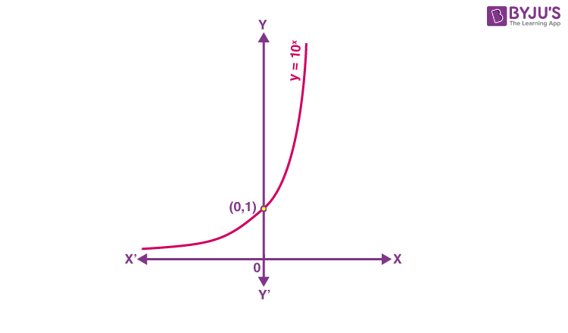

Some of the essential considerations on the logarithm function to any base b > 1 are listed below:

* It is not possible to derive a meaningful definition of the logarithm for non-positive numbers, i.e. for negative numbers. So, the domain of the log function is the set of positive real numbers, i.e. R+.
* The range of the log function is the set of all real numbers.
* The point (1, 0) is always on the graph of the log function.
* The log function is ever-increasing, i.e., as we move from left to right the graph rises above.
* For the value of x quite near to zero, the value of log x can be made lesser than any given real number. That means, in quadrant IV, the graph approaches the y-axis but never meets it.

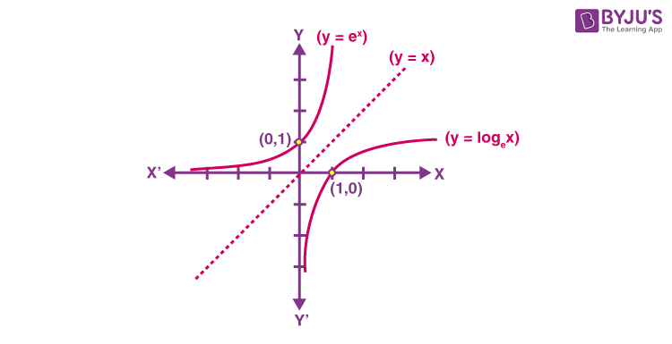

In the above graph of y = ex and y = ln x, we observe that the two curves are the mirror images of each other reflected over the line y = x.

**Rules of Exponential and Logarithmic Functions**

Below are the rules of exponential functions and logarithmic functions.

|  |  |
| --- | --- |
| **Exponential Rules** | **Logarithmic Rules** |
| * ax ay = ax+y * ax/ay = ax-y * (ax)y = axy * Axbx= (ab)x * (a/b)x= ax/bx * a0= 1 * a-x = 1/ ax | * logb (xy) = logb x + logb y * logb (x/y) = logb x – logb y * logb xm = m logb x * logb p2 = logb p + logb p = 2 log p * loga p = (logb p)/ (logb a) * logb 1 = 0 * logb b = 1 * logb bx = x |